

**C.I.T.L. EXPERIMENT 7**

**Submitted By:**

| Akash Panicker | 2021300089 |
| --- | --- |
| Mahesh Patil | 2021300095 |
| Rohit Phalke | 2021300100 |
| Adwait Purao | 2021300101 |

**Submitted To:**

Prof. Sunil Ghane

**Inventory Management System**

**Aim:**

Integration of web services using open source integration tools like Mulesoft.

**Problem Statement:**

Develop an inventory management system for a retail store that efficiently tracks and manages the inventory of products. The system should provide real-time updates on stock levels, generate alerts for low stock items, enable easy addition and removal of products, and offer insights into sales trends to optimize restocking decisions.

**Theory:**

# **What is MuleSoft?**

**MuleSoft is a platform that gives IT the tools to automate everything. This includes integrating data and systems, automating workﬂows and processes, and creating incredible digital experiences — all on a single, easy-to-use platform. With our unique approach, IT creates digital building blocks that teams can use as they need, all with the right security, governance, and compliance measures built in.**

# **What is Shopify?**

**Shopify is a user-friendly e-commerce platform that helps small businesses build an online store and sell online through one streamlined dashboard. Shopify merchants can build a modern online store and sell on social media sites, seller marketplaces, other blogs, and websites and via email, text and chat. In-person selling is a snap on Shopify too, with its built-in point-of-sale (POS) for retail stores, pop-up shops, market sales and more. Shopify is a subscription-based software-as-a-service (SaaS) sales platform. Shopify offers four standard store subscription plans with fees starting at INR 1,994 per month. All standard plans support a branded online store and a full array of in-person and online selling tools.**

**Shopify is an e-commerce platform that provides businesses with the tools they need to create and operate an online store. It is designed to simplify the process of setting up and managing an online retail business.**

**Here are some key reasons why businesses use Shopify:**

**● User-Friendly:** Shopify offers an intuitive and user-friendly interface, making it accessible to businesses of all sizes, including those without extensive technical expertise.

**● E-Commerce Features:** It comes with a wide range of e-commerce features, including product management, inventory control, payment processing, and order fulﬁllment.

**● Customization:** Businesses can customize the look and feel of their online stores using themes and templates. They can also add functionality through apps and integrations available in the Shopify App Store.

**● Scalability:** Shopify can accommodate both small and large businesses, allowing them to scale their online operations as they grow.

**● Security:** Shopify provides security features to protect sensitive customer data and ensure secure transactions.

**● Mobile-Friendly:** Shopify offers mobile-responsive designs, enabling businesses to reach customers on various devices.

**● MuleSoft:** MuleSoft is an integration platform that helps organizations connect and integrate various systems and applications to streamline data ﬂow and business processes. Here's why MuleSoft is used:

**● Integration:** MuleSoft simpliﬁes the integration of disparate systems, databases, applications, and APIs, making it easier for organizations to share data and automate processes.

**● API Management:** It provides robust API management capabilities, allowing organizations to create, publish, secure, and monitor APIs.

**❖ Implementation:**

In this experiment, we created an app store in Shopify. After creating the app, we conﬁgured the access tokens, and we got the API credentials. In the Anypoint studio, we ﬁrst tested the Shopify API credentials and then connected and tested out MongoDB database using connection string. In citl.xml ﬁle, we added “Logger” and “Insert document” function, ﬁrst to get the customer data in Anypoint studio and second to insert the data in MongoDB database. The last step is to add the #[payload] setting in the Logger Message Flow setup to ensure Shopify and MuleSoft communication connectivity. Therefore, now after creation of a customer, its details will get added to the database.

**Screenshots:**

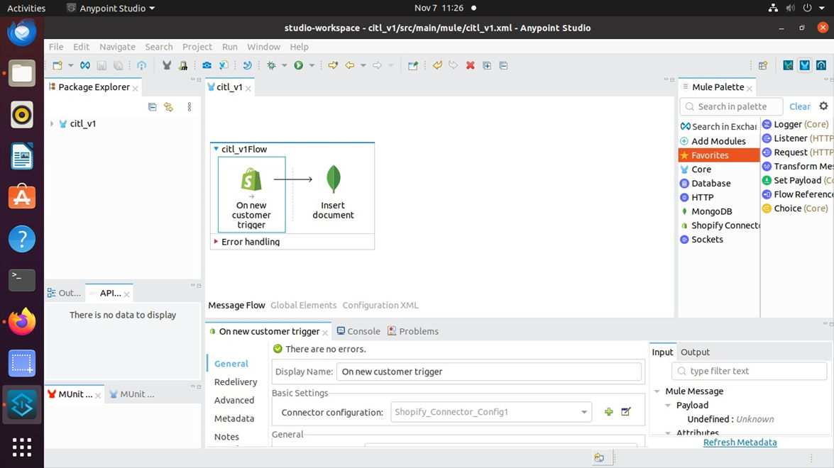

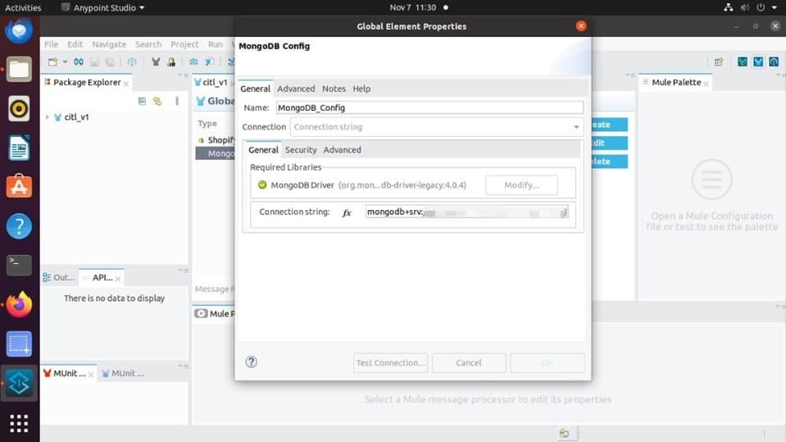

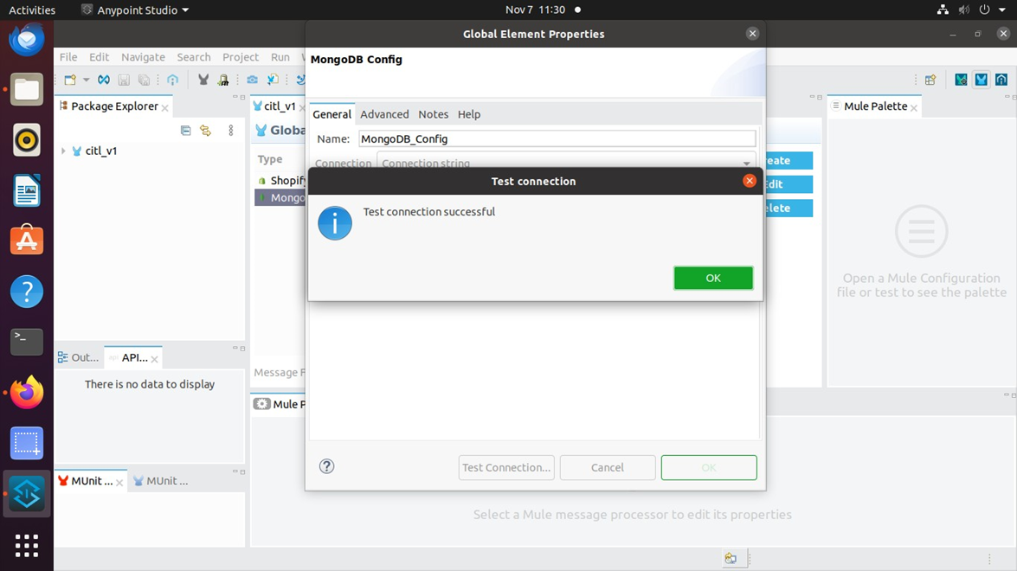

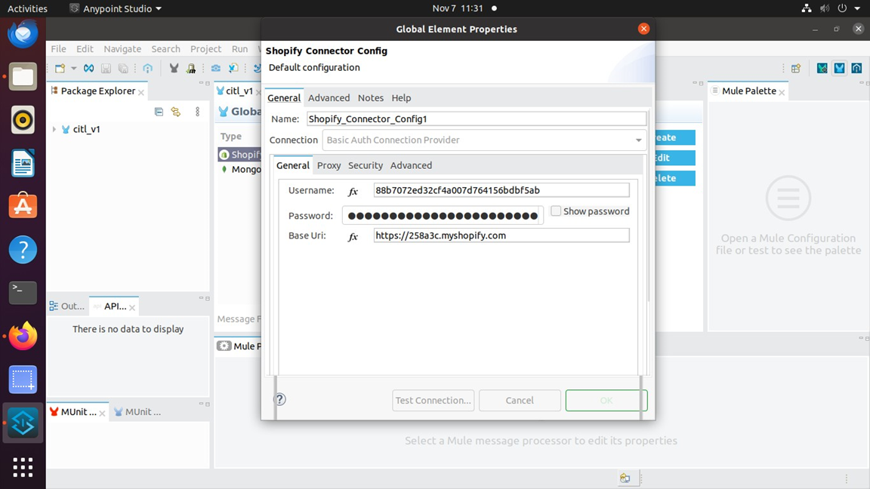

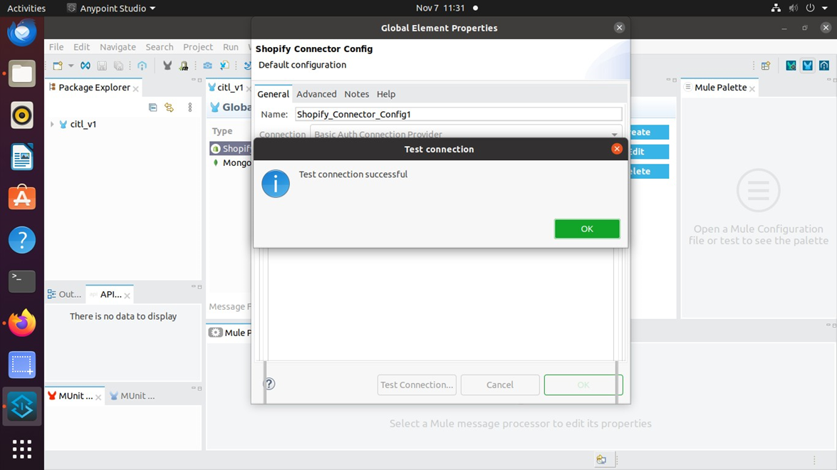

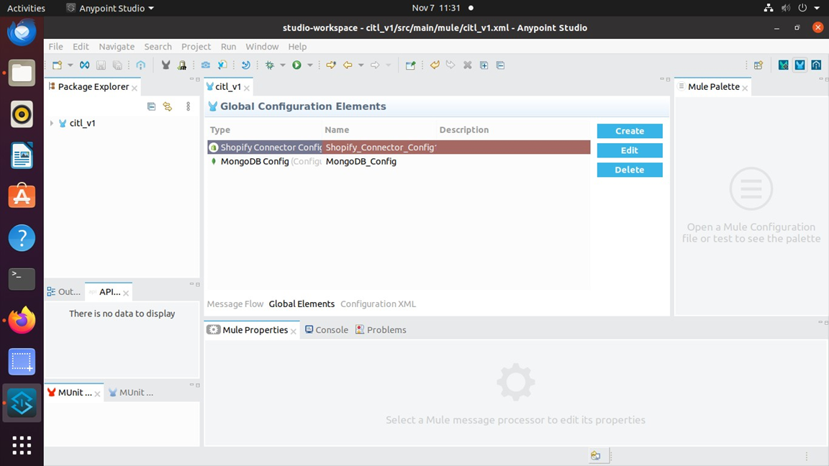

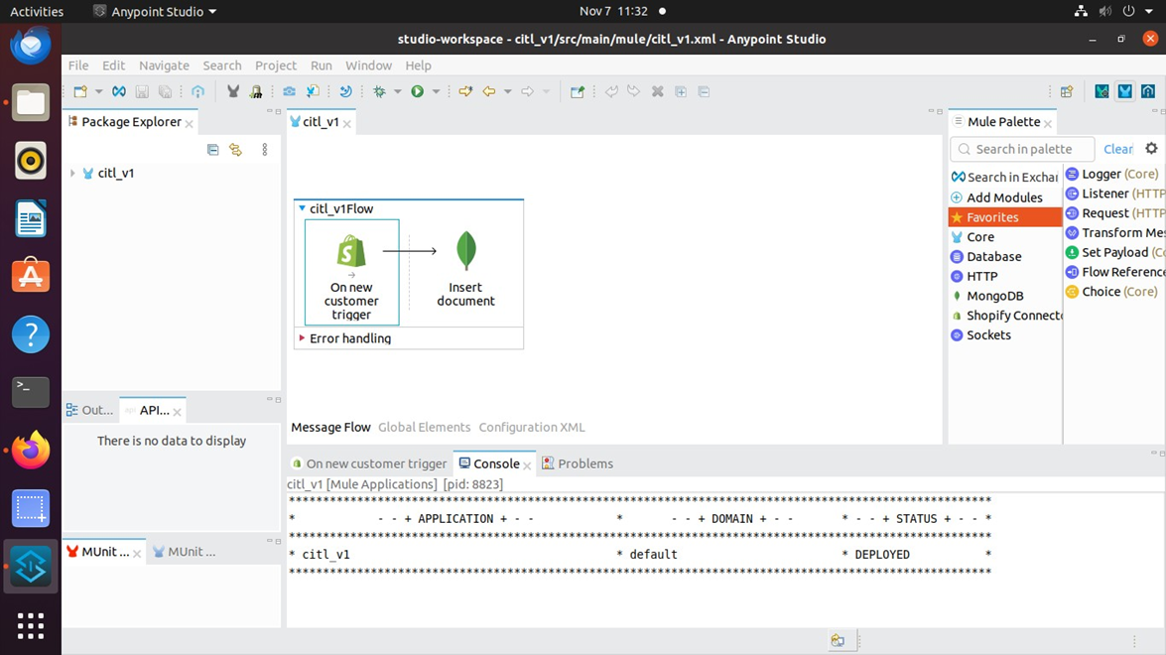

**Adding Users (Customers) to Shopify App**

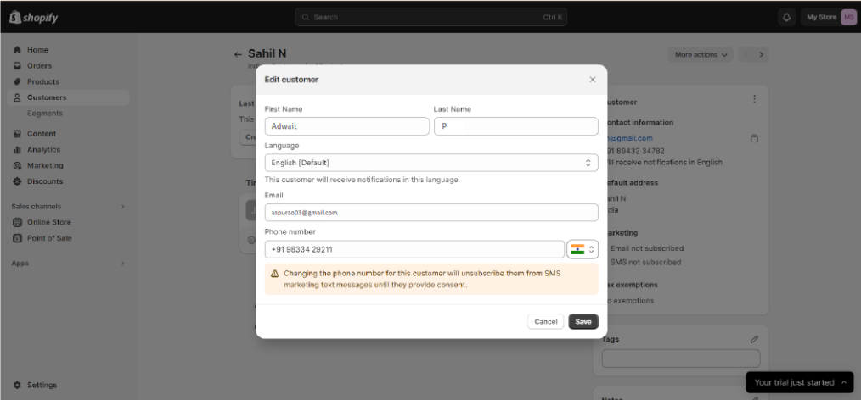

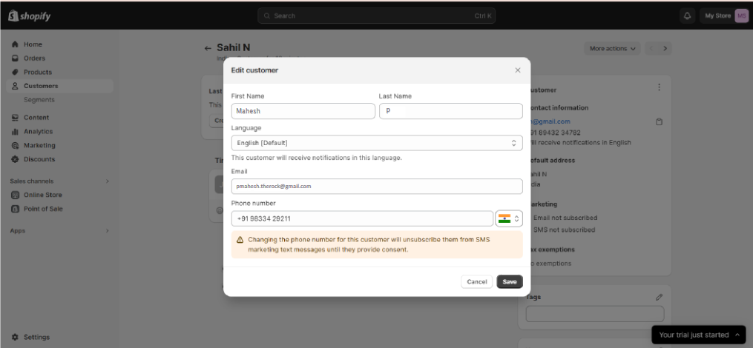

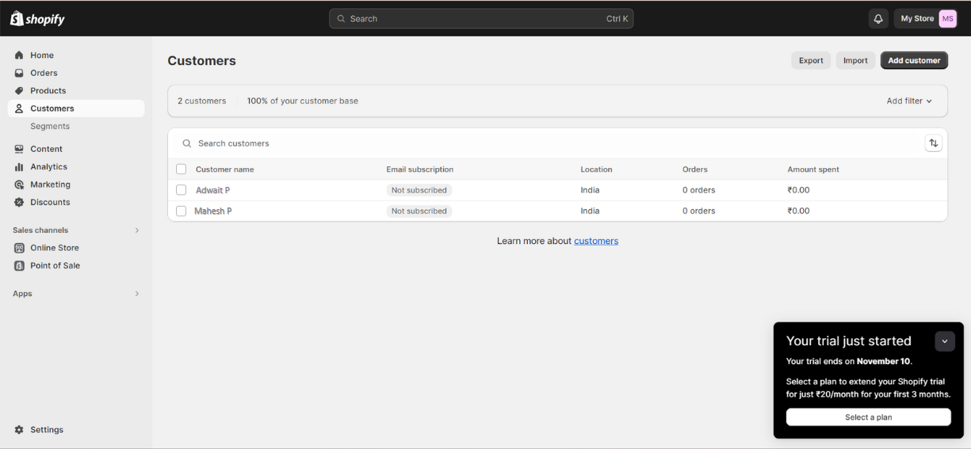

**MongoDB Database**

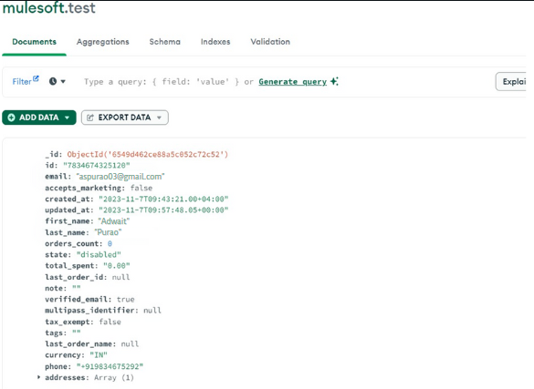

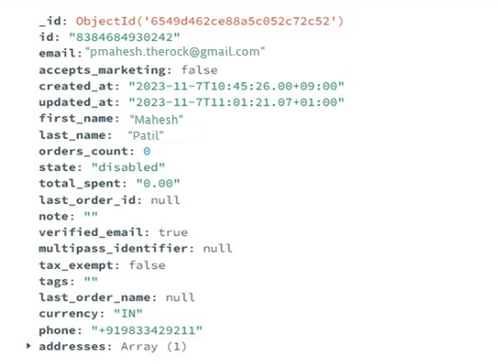

**Conclusion:**

In conclusion, the experiment provided valuable insights into API testing and integration using MuleSoft. By utilizing the Anypoint Studio platform, we were able to effectively simulate and manage various API scenarios.

This hands-on experience not only deepened our understanding of MuleSoft’s capabilities but also highlighted its efficiency in API lifecycle management. From design and development to testing and deployment, MuleSoft proved to be a robust tool for handling complex API integrations.

This experiment underscores the importance of practical learning in comprehending and mastering new technologies.